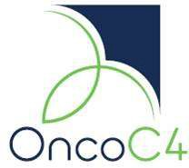

Associate Scientist for Antibody/Protein Expression

Position:
The individual will work as part of the antibody/protein production team to support on-going projects. The successful candidate will possess relevant protein expression/characterization skills and techniques for antibodies and fusion proteins. Strong organizational skills will be necessary to support protein characterization needs for multiple projects.

Key responsibilities:
The Associate Scientist will report to Senior Director of preclinical research and involved in the production and characterization of recombinant antibodies and fusion proteins. Candidate must be motivated and expected to maintain good documentation of lab work.

Qualifications:
- Bachelor’s or master’s degree in biology, biochemistry, immunology or equivalent, with a minimum of 2 years of working experience in the related field.
- Hands-on experience in cell culture, transfection, and antibody/protein production.
- Hands-on experience with bioanalytical assays for antibody/protein characterization, such as SE-HPLC, CE-SDS, cIEF, ELISA, ligand binding assays and functional cell-based assays. Experience in Biacore/Octet and flow cytometry is a plus.
- Good communication skills and the ability to interpret, summarize and present scientific results in a clear and accurate manner.
- Self-motivated individual with good time management skills and multitasking capabilities to work in a team-oriented environment.

